Light Bulb with AC Relay

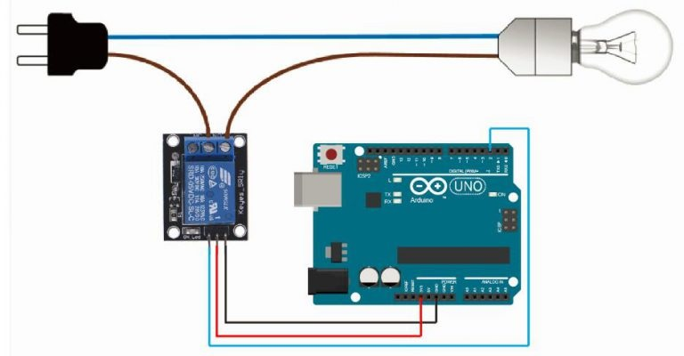

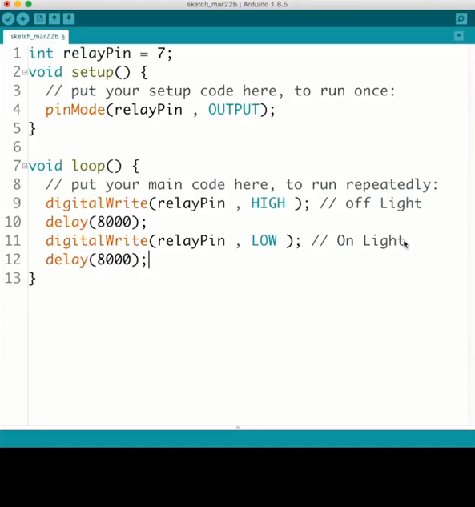
Ultrasonic Sensor

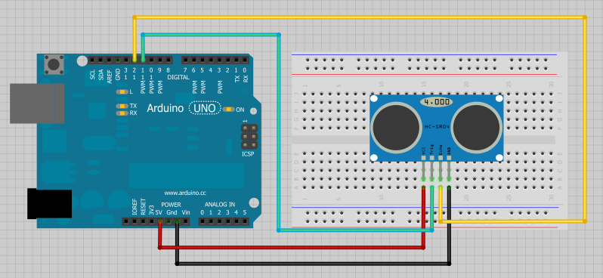

- const int trigPin=9;
- const int echoPin=10;
- long duration;
- int distance;
- voidsetup(){
- pinMode(trigPin, OUTPUT); // Sets the trigPin as an Output
- pinMode(echoPin, INPUT); // Sets the echoPin as an Input
- Serial.begin(9600); // Starts the serial communication
- }
- voidloop(){
- digitalWrite(trigPin, LOW);
- delayMicroseconds(2);
- digitalWrite(trigPin, HIGH);
- delayMicroseconds(10);
- digitalWrite(trigPin, LOW);
- duration =pulseIn(echoPin, HIGH);
distance= duration*0.034/2;
- Serial.print("Distance: ");
- Serial.println(distance);}

